**Stranger in the Village Essay Rubric**

**Stranger in the Village Essay Rubric**

**Name: _______________________________________________**

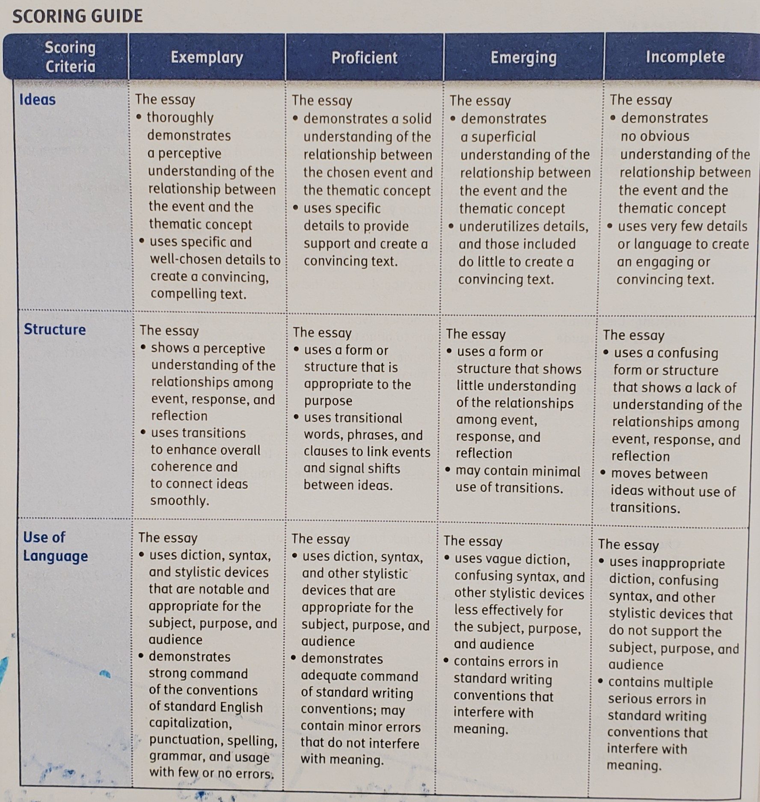

**Name: _______________________________________________**

